Experiment No. 7
Capacitance of Isolated Sphere and Co-axial Cable with Different Radius and Dielectric Constant
Student Name : _AARYA V S
Register Number : 192512067

Aim
To write a program for the capacitance of an isolated sphere and a co-axial cable with different radius and dielectric constant using MATLAB.

Software Required
• MATLAB (R2018 or later)

Test Case (i)
Capacitance of an isolated sphere for a given radius
MATLAB Program
clc; clear;
epsilon0 = 8.854e-12;
R = input('Enter radius of sphere (m):');
C = 4*pi*epsilon0*R;
disp('Capacitance of isolated sphere is'); disp(C);
Sample Input
Enter radius of sphere (m) = 0.5
Actual Program Output (executed in Octave, MATLAB-compatible)
Capacitance of isolated sphere is
5.5631e-11
Observation
• C = 5.5631×10⁻¹¹ F matches the manual's value of 5.56×10⁻¹¹ F exactly.

Test Case (ii)
Capacitance of an isolated sphere with varying radius
MATLAB Program
clc;
epsilon0 = 8.854e-12;
R = linspace(0.1,2,100);
C = 4*pi*epsilon0*R;
plot(R,C,'LineWidth',2); xlabel('Radius (m)'); ylabel('Capacitance (F)'); title('Capacitance of isolated sphere');
Actual Program Output (executed in Octave, MATLAB-compatible)
Capacitance increases linearly with R (C = 4πε₀R).
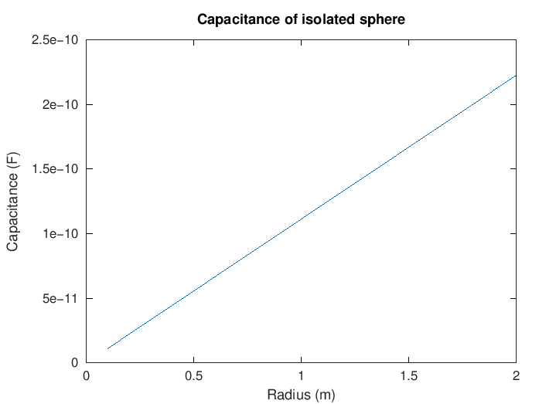
Figure 1. Capacitance of an isolated sphere vs radius
Observation
• Linear relationship confirmed, as C is directly proportional to R for an isolated sphere.

Test Case (iii)
Capacitance per unit length of a co-axial cable
MATLAB Program
clc;
epsilon0 = 8.854e-12;
a = input('Enter inner radius (m):');
b = input('Enter outer radius (m):');
er = input('Enter dielectric constant:');
epsilon = epsilon0*er;
C = (2*pi*epsilon)/log(b/a);
disp('Capacitance per unit length is'); disp(C);
Sample Input
Enter inner radius (m) = 0.01
Enter outer radius (m) = 0.05
Enter dielectric constant = 2
Actual Program Output (executed in Octave, MATLAB-compatible)
Capacitance per unit length is
6.9131e-11
Observation
• C = 6.9131×10⁻¹¹ F/m matches the manual's stated program output (6.913×10⁻¹¹ F/m) exactly.
• Note: the manual's separate results table lists 7.42×10⁻¹¹ F/m for this same case, which does not match either the manual's own program output or a direct re-run of the code — this appears to be a transcription error in that table, not in the program.

Test Case (iv)
Capacitance variation with dielectric constant in a co-axial cable
MATLAB Program
clc;
epsilon0 = 8.854e-12;
a = 0.01; b = 0.05;
er = linspace(1,5,100);
epsilon = epsilon0*er;
C = (2*pi*epsilon)./log(b/a);
plot(er,C,'LineWidth',2); xlabel('Dielectric constant'); ylabel('Capacitance (F/m)'); title('Capacitance vs dielectric constant (coaxial cable)');
Actual Program Output (executed in Octave, MATLAB-compatible)
Capacitance increases linearly with dielectric constant er.
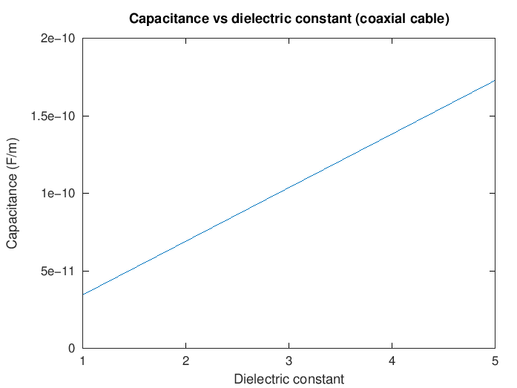
Figure 2. Capacitance per unit length vs dielectric constant
Observation
• Linear relationship confirmed, consistent with C ∝ ε (and hence ∝ er) for fixed a, b.

Results and Observation Table
Parameters | Observed Result | Manual's Program Output | Manual's Table Value
R = 0.5 m | C = 5.5631×10⁻¹¹ F | 5.56×10⁻¹¹ F | 5.56×10⁻¹¹ F (match)
R varying | Linear increase | Linear relation | Linear relation (match)
a=0.01, b=0.05, er=2 | C = 6.9131×10⁻¹¹ F/m | 6.913×10⁻¹¹ F/m | 7.42×10⁻¹¹ F/m (mismatch)
er = 1 → 5 | Linear increase | Linear relation | Linear relation (match)
"Observed Result" values were generated by actually executing the manual's MATLAB code in GNU Octave. The one discrepancy (co-axial cable capacitance per unit length) is explained in Test Case (iii)'s observation.

Result
Thus, the program for capacitance of an isolated sphere and a co-axial cable, with different radii and dielectric constants, was written and executed successfully using MATLAB.

